1. Correlation: Correlation Does Not Mean Causation
One of the major misconceptions about correlation is that a relationship between two variables means causation; that is, one variable causes changes in the other variable. There is a particular tendency to make this causal error, when the two variables seem to be related to each other.
What is one instance where you have seen correlation misinterpreted as causation? Please describe.
OR
2. Linear Regression
Linear regression is used to predict the value of one variable from another variable. Since it is based on correlation, it cannot provide causation. In addition, the strength of the relationship between the two variables affects the ability to predict one variable from the other variable; that is, the stronger the relationship between the two variables, the better the ability to do prediction.
What is one instance where you think linear regression would be useful to you in your workplace or chosen major? Please describe including why and how it would be used.
Solution 2. Linear regression
Correlation quantifies the strength of the linear relationship between a pair of variables, whereas regression expresses the relationship in the form of an equation. The goal of a correlation analysis is to see whether two measurement variables co vary, and to quantify the strength of the relationship between the variables, whereas regression expresses the relationship in the form of an equation.
For example, in students taking a Maths and English test, we could use correlation to determine whether students who are good at Maths tend to be good at English as well, and regression to determine whether the marks in English can be predicted for given marks in Maths.
In the example, if we are trying to determine whether the marks in English can be predicted for given marks in Maths, then marks in Maths is the independent variable and marks in English is a dependent variable.'
If there are more than one independent variable, then a simple linear regression model is unsuitable for the prediction model. In such cases, a Multiple Regression model is used.
A multiple linear regression model shows the relationship between the dependent variable and multiple (two or more) independent variables.

10.1.2
Table #10.1.6 contains the value of the house and the amount of rental income in a year that the house brings in ("Capital and rental," 2013). Create a scatter plot and find a regression equation between house value and rental income. Then use the regression equation to find the rental income a house worth $230,000 and for a house worth $400,000. Which rental income that you calculated do you think is closer to the true rental income? Why?

Table #10.1.6: Data of House Value versus Rental
Value | Rental | Value | Rental | Value | Rental | Value | Rental
81000 | 6656 | 77000 | 4576 | 75000 | 7280 | 67500 | 6864
95000 | 7904 | 94000 | 8736 | 90000 | 6240 | 85000 | 7072
121000 | 12064 | 115000 | 7904 | 110000 | 7072 | 104000 | 7904
135000 | 8320 | 130000 | 9776 | 126000 | 6240 | 125000 | 7904
145000 | 8320 | 140000 | 9568 | 140000 | 9152 | 135000 | 7488
165000 | 13312 | 165000 | 8528 | 155000 | 7488 | 148000 | 8320
178000 | 11856 | 174000 | 10400 | 170000 | 9568 | 170000 | 12688
200000 | 12272 | 200000 | 10608 | 194000 | 11232 | 190000 | 8320
214000 | 8528 | 208000 | 10400 | 200000 | 10400 | 200000 | 8320
240000 | 10192 | 240000 | 12064 | 240000 | 11648 | 225000 | 12480
289000 | 11648 | 270000 | 12896 | 262000 | 10192 | 244500 | 11232
325000 | 12480 | 310000 | 12480 | 303000 | 12272 | 300000 | 12480

Now for regression line:
- Firstly enter the data in the excel spreadsheet
- Then go to 'Data' option in the tool bar.
- Click on 'Data Analysis', then a dialog box will appear.
- In the dialog box, select regression and click on OK.
- Then in 'Input Y range:' drag Rental data and in 'Input X range:' drag Value data and finally click on OK.
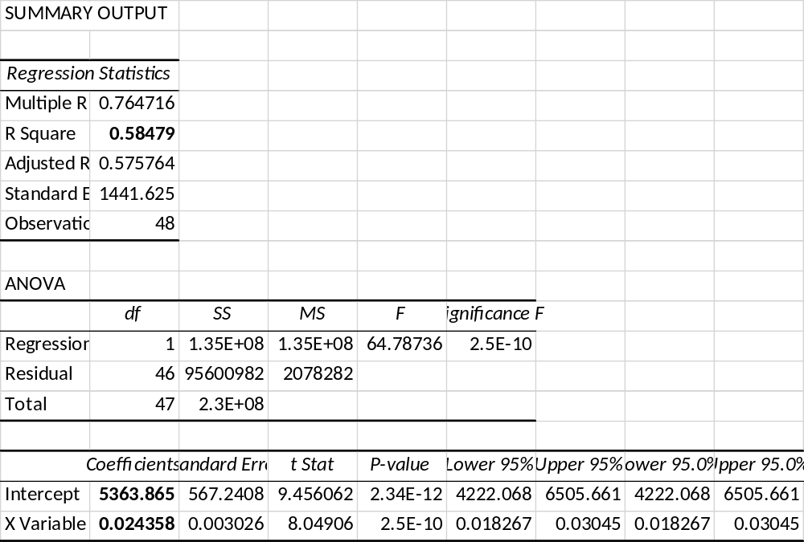

Therefore our line of regression is given by:
Y = 5363.86 + 0.02X.
Now from the summary output our R-squared value is 0.5848 or 58.48%.
(a). For house worth $230000 i.e., X is 230000. Now putting value of X in our regression equation we get:
Y = 5363.86 + 0.02(230000) = 5363.86 + 5602.40 = 10966.26
Therefore the rental income of house worth $230000 is $10966.26
(b). For house worth $400000 i.e., X is 400000. Now putting value of X in our regression equation we get:
Y = 5363.86 + 0.02(400000) = 5363.86 + 9743.30 = 15107.16
Therefore the rental income of house worth $400000 is $15107.16

Now for the construction of scatterplot in excel, follow the below steps:
- First type the data into excels spreadsheet.
- Then select the data and click on insert option in toolbar.
- Then under the chart section, select scatterplot and click oK.
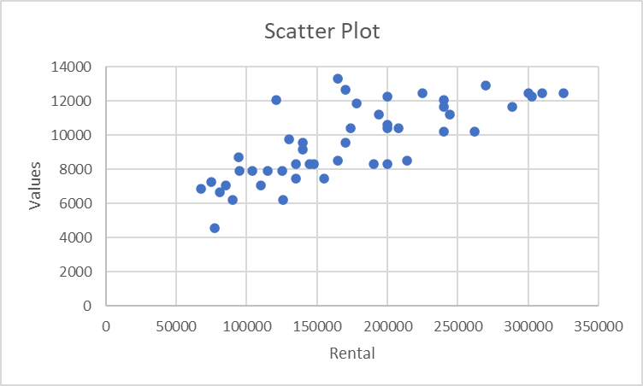

10.1.4
The World Bank collected data on the percentage of GDP that a country spends on health expenditures ("Health expenditure," 2013) and also the percentage of women receiving prenatal care ("Pregnant woman receiving," 2013). The data for the countries where this information are available for the year 2011 is in table #10.1.8. Create a scatter plot of the data and find a regression equation between percentage spent on health expenditure and the percentage of women receiving prenatal care. Then use the regression equation to find the percent of women receiving prenatal care for a country that spends 5.0% of GDP on health expenditure and for a country that spends 12.0% of GDP. Which prenatal care percentage that you calculated do you think is closer to the true percentage? Why?

Table #10.1.8: Data of Health Expenditure versus Prenatal Care
Health Expenditure (% of GDP) | Prenatal Care (%)
9.6 | 47.9
3.7 | 54.6
5.2 | 93.7
5.2 | 84.7
10.0 | 100.0
4.7 | 42.5
4.8 | 96.4
6.0 | 77.1
5.4 | 58.3
4.8 | 95.4
4.1 | 78.0
6.0 | 93.3
9.5 | 93.3
6.8 | 93.7
6.1 | 89.8

Now for regression line:
- Firstly enter the data in the excel spreadsheet
- Then go to 'Data' option in the tool bar.
- Click on 'Data Analysis', then a dialog box will appear.
- In the dialog box, select regression and click on OK.
- Then in 'Input Y range:' drag Parental care data and in 'Input X range:' drag Health expenditure data and finally click on OK.
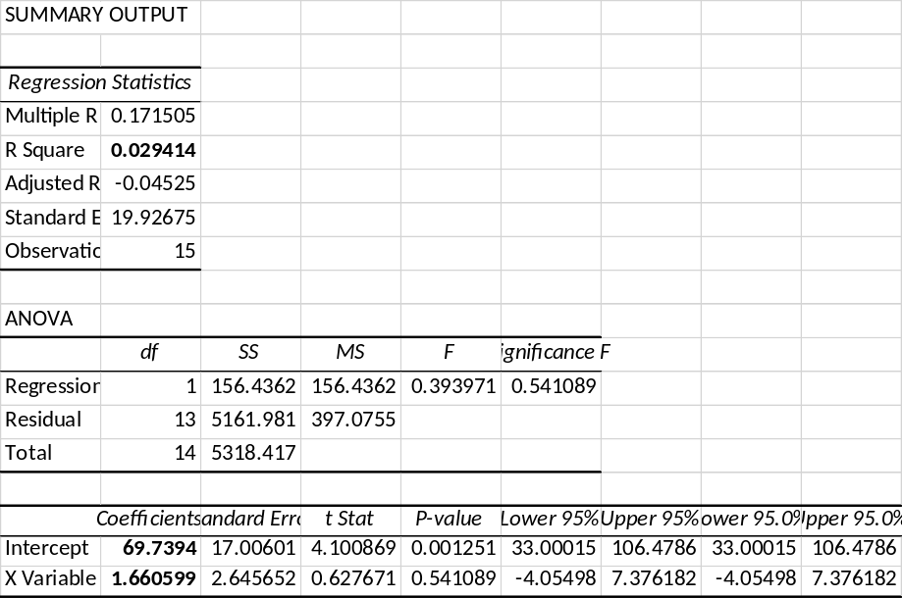
Estimated regression line for the given data
Y = 69.7394 + 1.6606x
Now for the construction of scatterplot in excel, follow the below steps:
- First type the data into excels spreadsheet.
- Then select the data and click on insert option in toolbar.
- Then under the chart section, select scatterplot and click oK.
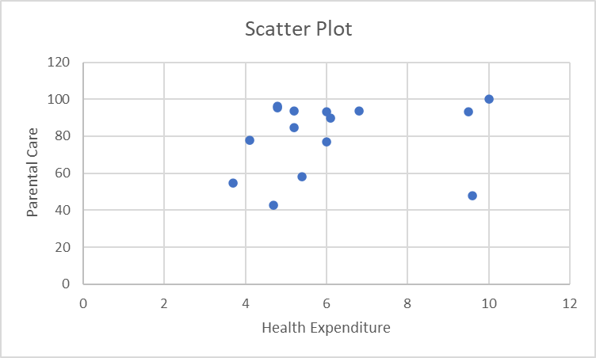

a)calculate the percent of women receiving parental care for a country tht spends 5.0% of GDP Health expenditure
y = 69.7394 + 1.6606 *5
y = 78.0424
b)Calculate the percent of women receiving parental care for a country tht spends 12.0% of GDP Health expenditure
y= 69.7394+1.6606*12
y = 89.6666
From the given data, it is observed that the values of Y are not given for x =5 and x = 12. Therefore, it is difficult to tell which parental care that was calculated is closer to the true percentage.

10.2.2
Table #10.1.6 contains the value of the house and the amount of rental income in a year that the house brings in ("Capital and rental," 2013). Find the correlation coefficient and coefficient of determination and then interpret both.

Table #10.1.6: Data of House Value versus Rental
Value | Rental | Value | Rental | Value | Rental | Value | Rental
81000 | 6656 | 77000 | 4576 | 75000 | 7280 | 67500 | 6864
95000 | 7904 | 94000 | 8736 | 90000 | 6240 | 85000 | 7072
121000 | 12064 | 115000 | 7904 | 110000 | 7072 | 104000 | 7904
135000 | 8320 | 130000 | 9776 | 126000 | 6240 | 125000 | 7904
145000 | 8320 | 140000 | 9568 | 140000 | 9152 | 135000 | 7488
165000 | 13312 | 165000 | 8528 | 155000 | 7488 | 148000 | 8320
178000 | 11856 | 174000 | 10400 | 170000 | 9568 | 170000 | 12688
200000 | 12272 | 200000 | 10608 | 194000 | 11232 | 190000 | 8320
214000 | 8528 | 208000 | 10400 | 200000 | 10400 | 200000 | 8320
240000 | 10192 | 240000 | 12064 | 240000 | 11648 | 225000 | 12480
289000 | 11648 | 270000 | 12896 | 262000 | 10192 | 244500 | 11232
325000 | 12480 | 310000 | 12480 | 303000 | 12272 | 300000 | 12480

Now for correlation coefficient:
- Firstly enter the data in the excel spreadsheet
- Then go to 'Data' option in the tool bar.
- Click on 'Data Analysis', then a dialog box will appear.
- In the dialog box, select regression and click on OK.
- Then in 'Input Y range:' drag Rental data and in 'Input X range:' drag Value data and finally click on OK.
$$R^{2}=0.58479 \sim 0.5848$$
Hence coefficient of determination is 58.48 %
Interpretation:
R -squared is statistical measure which shows that how close is our values to the best fitted line or we can say that how the values is coreleated to each other.here value of house is 58.48 % somewhat releated to Rental.

10.2.4
The World Bank collected data on the percentage of GDP that a country spends on health expenditures ("Health expenditure," 2013) and also the percentage of women receiving prenatal care ("Pregnant woman receiving," 2013). The data for the countries where this information is available for the year 2011 are in table #10.1.8. Find the correlation coefficient and coefficient of determination and then interpret both.

Table #10.1.8: Data of Health Expenditure versus Prenatal Care
Health Expenditure (% of GDP) | Prenatal Care (%)
9.6 | 47.9
3.7 | 54.6
5.2 | 93.7
5.2 | 84.7
10.0 | 100.0
4.7 | 42.5
4.8 | 96.4
6.0 | 77.1
5.4 | 58.3
4.8 | 95.4
4.1 | 78.0
6.0 | 93.3
9.5 | 93.3
6.8 | 93.7
6.1 | 89.8

Now for correlation coefficient:
- Firstly enter the data in the excel spreadsheet
- Then go to 'Data' option in the tool bar.
- Click on 'Data Analysis', then a dialog box will appear.
- In the dialog box, select regression and click on OK.
- Then in 'Input Y range:' drag Parental care data and in 'Input X range:' drag Health expenditure data and finally click on OK.
$$R^{2}=0.02941 \sim 0.0294$$
Hence coefficient of determination is 2.94 %
Interpretation:
R -squared is statistical measure which shows that how close is our values to the best fitted line or we can say that how the values is coreleated to each other.here value of healthcare expenditure is 2.94 % somewhat releated to Parental care.

10.3.2
Table #10.1.6 contains the value of the house and the amount of rental income in a year that the house brings in ("Capital and rental," 2013).
Test at the 5% level for a positive correlation between house value and rental amount.

Table #10.1.6: Data of House Value versus Rental
Value | Rental | Value | Rental | Value | Rental | Value | Rental
81000 | 6656 | 77000 | 4576 | 75000 | 7280 | 67500 | 6864
95000 | 7904 | 94000 | 8736 | 90000 | 6240 | 85000 | 7072
121000 | 12064 | 115000 | 7904 | 110000 | 7072 | 104000 | 7904
135000 | 8320 | 130000 | 9776 | 126000 | 6240 | 125000 | 7904
145000 | 8320 | 140000 | 9568 | 140000 | 9152 | 135000 | 7488
165000 | 13312 | 165000 | 8528 | 155000 | 7488 | 148000 | 8320
178000 | 11856 | 174000 | 10400 | 170000 | 9568 | 170000 | 12688
200000 | 12272 | 200000 | 10608 | 194000 | 11232 | 190000 | 8320
214000 | 8528 | 208000 | 10400 | 200000 | 10400 | 200000 | 8320
240000 | 10192 | 240000 | 12064 | 240000 | 11648 | 225000 | 12480
289000 | 11648 | 270000 | 12896 | 262000 | 10192 | 244500 | 11232
325000 | 12480 | 310000 | 12480 | 303000 | 12272 | 300000 | 12480

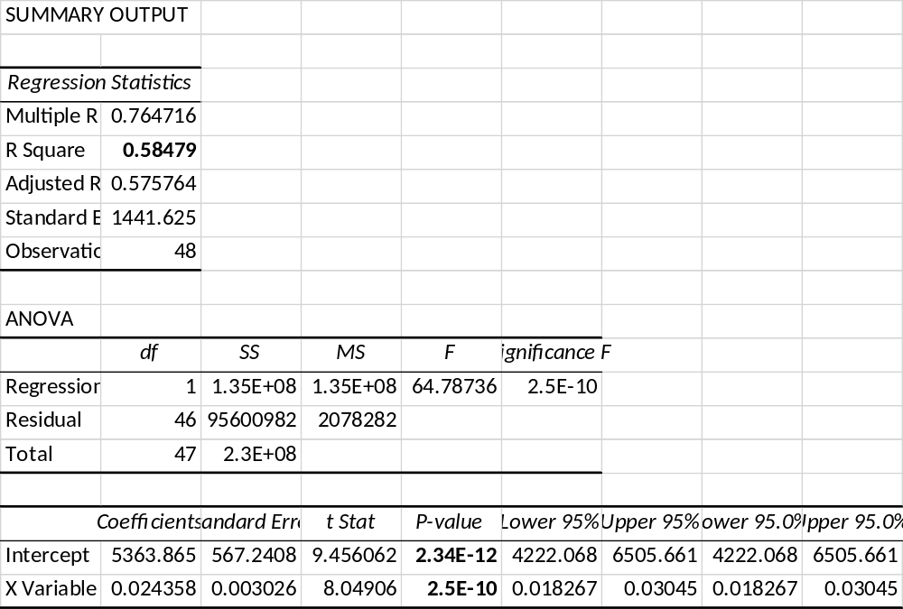
The hypothesis being tested is:
H₀: β₁ = 0
H₁: β₁ > 0
The p-value is 0.000.
Since the p-value (0.0000) is less than the significance level (0.05), we can reject the null hypothesis.
Therefore, we can conclude that there is a positive relationship between the value of the house and the rental income.

10.3.4
The World Bank collected data on the percentage of GDP that a country spends on health expenditures ("Health expenditure," 2013) and also the percentage of women receiving prenatal care ("Pregnant woman receiving," 2013). The data for the countries where this information is available for the year 2011 are in table #10.1.8.
Test at the 5% level for a correlation between percentage spent on health expenditure and the percentage of women receiving prenatal care.

Table #10.1.8: Data of Health Expenditure versus Prenatal Care
Health Expenditure (% of GDP) | Prenatal Care (%)
9.6 | 47.9
3.7 | 54.6
5.2 | 93.7
5.2 | 84.7
10.0 | 100.0
4.7 | 42.5
4.8 | 96.4
6.0 | 77.1
5.4 | 58.3
4.8 | 95.4
4.1 | 78.0
6.0 | 93.3
9.5 | 93.3
6.8 | 93.7
6.1 | 89.8

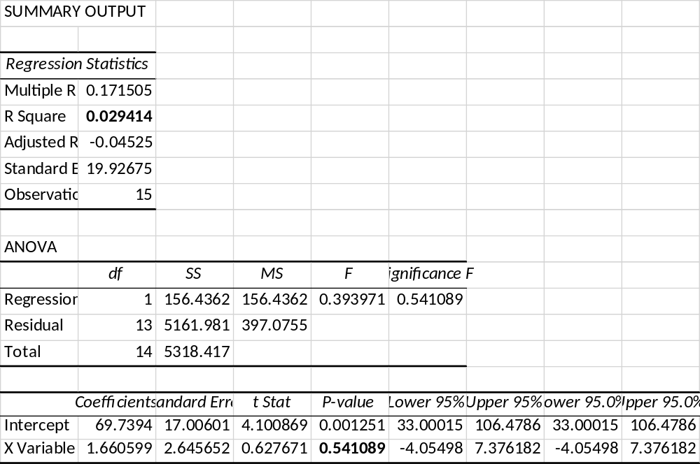
The hypothesis being tested is:
H₀: β₁ = 0
H₁: β₁ > 0
The p-value is 0.541.
Since the p-value (0.541) is greater than the significance level (0.05), we fail to reject the null hypothesis.
Therefore, we can conclude that there is no correlation between the Healthcare Expenditure and Parental care.

11.1.2

Researchers watched groups of dolphins off the coast of Ireland in 1998 to determine what activities the dolphins partake in at certain times of the day ("Activities of dolphin," 2013). The numbers in table #11.1.6 represent the number of groups of dolphins that were partaking in an activity at certain times of days. Is there enough evidence to show that the activity and the time period are independent for dolphins? Test at the 1% level.

Table #11.1.6: Dolphin Activity
Activity | Period |  |  |  | Row  Total
Activity | Morning | Noon | Afternoon | Evening | Row  Total
Travel | 6 | 6 | 14 | 13 | 39
Feed | 28 | 4 | 0 | 56 | 88
Social | 38 | 5 | 9 | 10 | 62
Column Total | 72 | 15 | 23 | 79 | 189

In this question we are given observed frequencies.
We calculate expected frequencies using the formula
$$E_{i} \left(for i^{th} cell\right)=\frac{row total×column total}{sample size}$$
Expected values are as follows
Activity | Period
Activity | Morning | Noon | Afternoon | Evening
Travel | 14.86 | 3.10 | 4.75 | 16.30
Feed | 33.52 | 6.98 | 10.71 | 36.78
Social | 23.62 | 4.92 | 7.54 | 25.92
Test static T is given by
$$T=\sum{\frac{{\left(O_{i}-E_{i}\right)}^{2}}{E_{i}} }=68.46$$
Critical value = $X_{α, df}^{2}= X_{0.01, 6}^{2}=16.812$
Since $T> X_{0.01, 6}^{2}$, we reject $H_{0}:independence$. We conclude that there is enough evidence to reject the claim that the 2 variables are not dependent.

11.1.4
A person’s educational attainment and age group was collected by the U.S. Census Bureau in 1984 to see if age group and educational attainment are related. The counts in thousands are in table #11.1.8 ("Education by age," 2013). Do the data show that educational attainment and age are independent? Test at the 5% level.
Table #11.1.8: Educational Attainment and Age Group
Education | Age Group |  |  |  |  | Row Total
Education | 25-34 | 35-44 | 45-54 | 55-64 | >64 | Row Total
Did not complete HS | 5416 | 5030 | 5777 | 7606 | 13746 | 37575
Competed HS | 16431 | 1855 | 9435 | 8795 | 7558 | 44074
College 1-3 years | 8555 | 5576 | 3124 | 2524 | 2503 | 22282
College 4 or more years | 9771 | 7596 | 3904 | 3109 | 2483 | 26863
Column Total | 40173 | 20057 | 22240 | 22034 | 26290 | 130794

null hypothesis: Ho: educational attainment and age are independent
alternate hypothesis: Ha: educational attainment and age are related
degree of freedom =(row-1)*(column-1) =(4-1)*(5-1)=12
for 12 degree of freedom and 0.05 level ; rejection region >21.026
applying chi square test of independence:
Expected | E_{i}=Σrow*Σcolumn/Σtotal | 25-34 | 35-44 | 45-54 | 55-64 | >64 | Total
 | not complete | 11541.053 | 5762.052 | 6389.192 | 6330.012 | 7552.692 | 37575
 | completed HS | 13537.202 | 6758.660 | 7494.272 | 7424.855 | 8859.011 | 44074
 | college 1-3 yrs | 6843.852 | 3416.900 | 3788.795 | 3753.701 | 4478.751 | 22282
 | college 4 or more yrs | 8250.893 | 4119.388 | 4567.741 | 4525.432 | 5399.546 | 26863
 | Total | 40173 | 20057 | 22240 | 22034 | 26290 | 130794
chi square χ² | =(O_{i}-E_{i})²/E_{i} | 25-34 | 35-44 | 45-54 | 55-64 | >64 | Total
 | not complete | 3250.680 | 93.005 | 58.658 | 257.211 | 5078.596 | 8738.150
 | completed HS | 618.597 | 3557.789 | 502.574 | 252.839 | 191.063 | 5122.862
 | college 1-3 yrs | 427.833 | 1364.310 | 116.647 | 402.846 | 871.581 | 3183.217
 | college 4 or more yrs | 280.058 | 2934.133 | 96.449 | 443.334 | 1575.362 | 5329.336
 | Total | 4577.168 | 7949.237 | 774.328 | 1356.231 | 7716.602 | 22373.566
here as test statisics =22373.566 is in rejeection region ; we reject null hypothesis
we have sufficient evidence at 0.05 level to conclude that educational attainment and age are related

11.2.4
In Africa in 2011, the number of deaths of a female from cardiovascular disease for different age groups are in table #11.2.6 ("Global health observatory," 2013). In addition, the proportion of deaths of females from all causes for the same age groups are also in table #11.2.6. Do the data show that the death from cardiovascular disease are in the same proportion as all deaths for the different age groups? Test at the 5% level.
Table #11.2.6: Deaths of Females for Different Age Groups
Age | 5-14 | 15-29 | 30-49 | 50-69 | Total
Cardiovascular Frequency | 8 | 16 | 56 | 433 | 513
All Cause Proportion | 0.10 | 0.12 | 0.26 | 0.52
H₀: the proportions are equalagainst
H₁:the proportions are different
The given data is presented as
Age | Observed frequency(f_{i}) | Expected probability | Expected frequency(np_{i}⁰) | (f_{i}-np_{i}⁰)/np_{i}⁰
5-14 | 8 | 0.1 | 51.3 | -0.844054581
15-29 | 16 | 0.12 | 61.56 | -0.740090968
30-49 | 56 | 0.26 | 133.38 | -0.580146949
50-69 | 433 | 0.52 | 266.76 | 0.623181886
Total | 513 | 1 | 513 | -1.541110611
The test statistic is given by
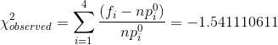
The test statistic follows chi square distribution with df 3
The critical value is obtained as
As the observed value is less than the critical value, we fail to reject the null hypothesis at 5% level of significance and hence conclude that the 2 proportions are not statistically different.
11.2.6
A project conducted by the Australian Federal Office of Road Safety asked people many questions about their cars. One question was the reason that a person chooses a given car, and that data is in table #11.2.8 ("Car preferences," 2013).
Table #11.2.8: Reason for Choosing a Car
Safety | Reliability | Cost | Performance | Comfort | Looks
84 | 62 | 46 | 34 | 47 | 27
Do the data show that the frequencies observed substantiate the claim that the reasons for choosing a car are equally likely? Test at the 5% level.
To test the hypothesis that the reasons for choosing a car are not equally likely at 5%
significance level.
The null hypothesis is that the reasons for choosing a car are equally likely.
The alternative hypothesis is that the reasons for choosing a car are not equally likely.
The chi-square test statistic for goodness-of-fittest is,
First, find frequency expected then compute chi-square test statistics.
The average for the observed frequencies computation is the frequencies expected. The
total for the expected frequency es must equal for the total observed frequencies.
The expected frequencies for category 1 are,
$$Expected frequency=\frac{84+62+46+34+47+27}{6}=50$$
The chi square test statistic for goodness to fit is,
$$χ^{2}=\sum{\frac{{\left(f_{0}-f_{e}\right)}^{2}}{f_{e}}}$$
$$χ^{2}=\frac{{\left(84-50\right)}^{2}}{50}+\frac{{\left(62-50\right)}^{2}}{50}+\frac{{\left(46-50\right)}^{2}}{50}+\frac{{\left(34-50\right)}^{2}}{50}+\frac{{\left(47-50\right)}^{2}}{50}+\frac{{\left(27-50\right)}^{2}}{50}$$
$$χ^{2}=42.2$$
Critical chi square $χ_{0.05,5}^{2}=11.071$
The conclusion is that chi square test statistic for goodness of fit test 42.2 is > critical chi square 11.071
Hence, reject null hypothesis at 5% level of significance. There is sufficient evidence to indicate that the reasons for choosing a car are not equal likely. The result is statistically significant.

